Lab 6 Code and Branch Coverage
Application: Irrigation Scheduler | Repository: L6_L7_37_irrigation_scheduler
Tests were added to measure line and branch coverage of irrigation_scheduler.py. Both suites achieved 100% coverage; all 48 tests, including the starter tests, passed.

Code coverage
12 test cases passed. All 38 executable statements were covered, with no missing lines. The tests cover irrigation decisions, water volume, invalid area, and schedule budget handling.
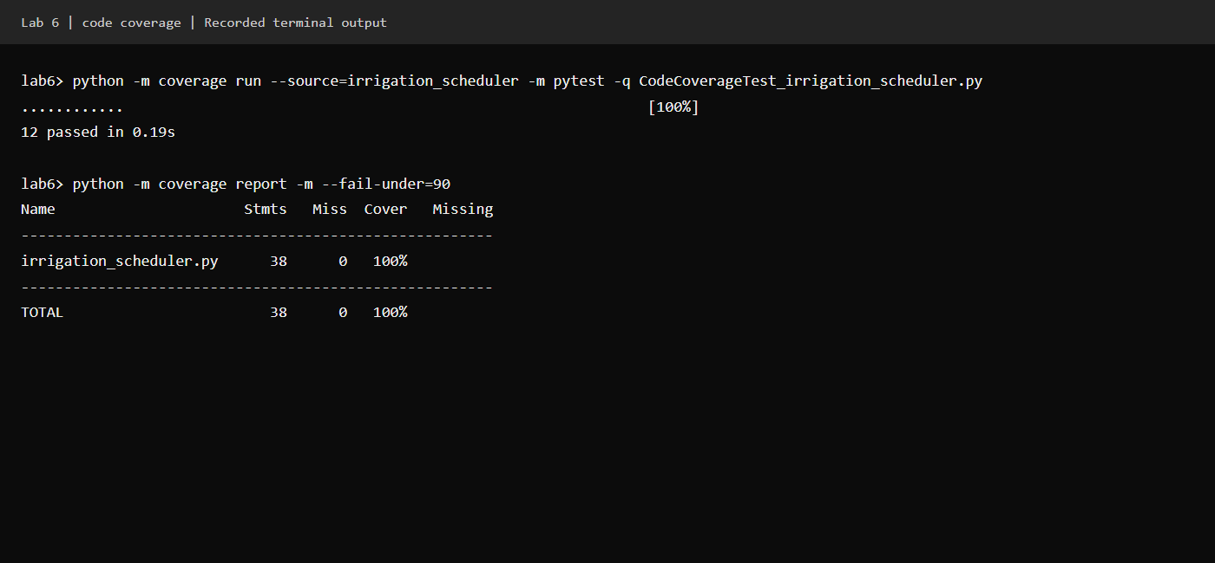

Branch coverage
34 test cases passed. All 28 branch outcomes were covered, with no partial branches. Tests include threshold values, empty schedules, exact budgets, skipped zones, and budget exhaustion.
